Warm Up: 3.2c: Linear Functions Name:

1. A sandwich is $2.25 and a slice of pizza is $1.50 in the cafeteria. Write an algebraic expression for this relationship. (use x for sandwiches and y for pizza)

2. You have $13.50 on your account, rewrite your expression as an equation equaling this.

a) How many sandwiches could you buy? Write this x-intercept as a point:

b) How many pizza slices could you buy? Write this y-intercept as a point:

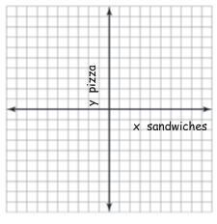
3. Use the x and y intercepts to graph the function?

4. Find the following:

a. f(2, 4) = b. f(4, 3) =

5. Put the function into slope intercept form by solving for y.

Extra Credit: Rewrite the equation by solving for x. Is this equation in slope intercept form?

